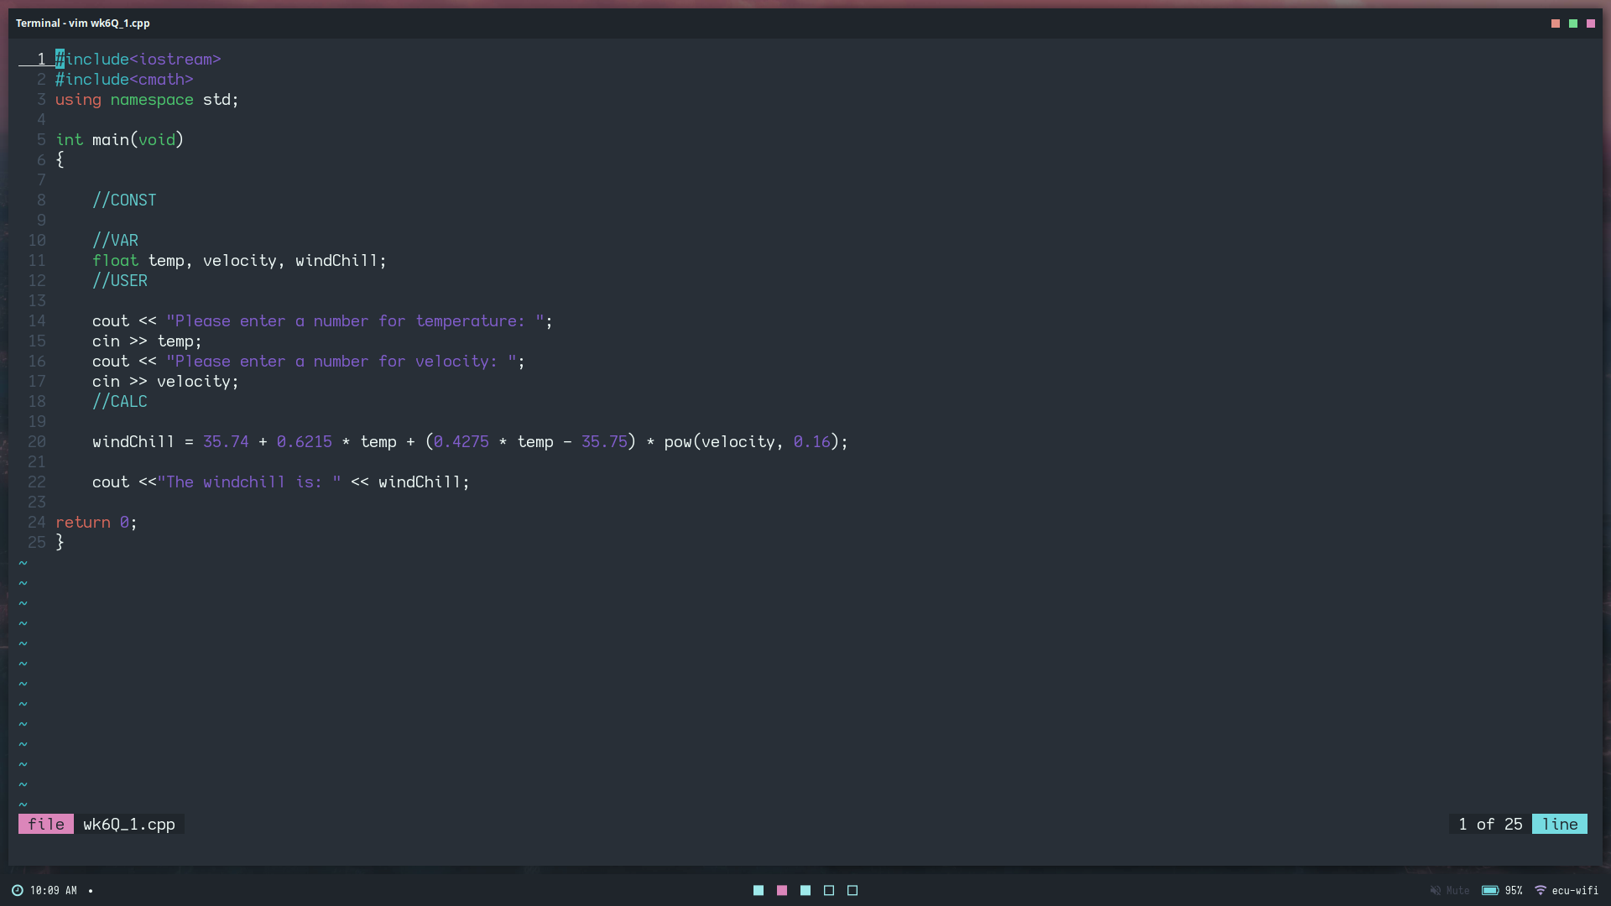
Question 1: INPUT

Question 1 : OUTPUT

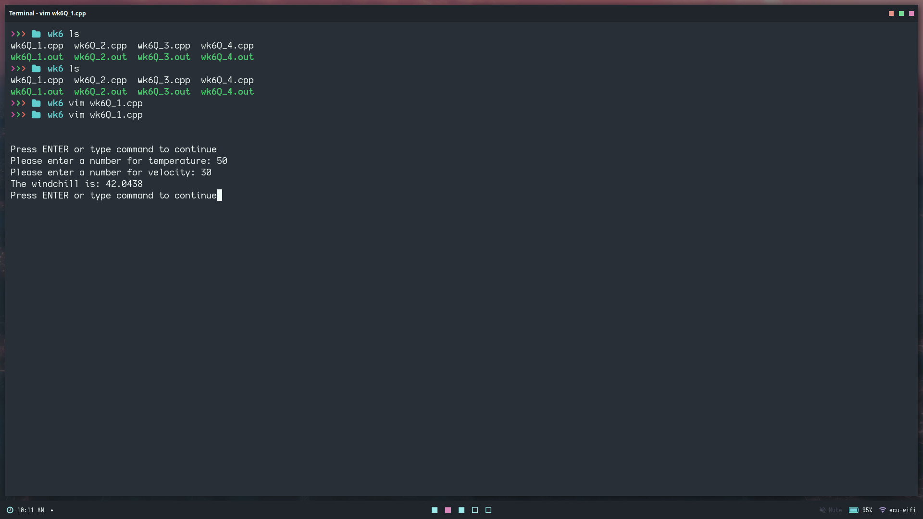

Question 2 INPUT AND OUTPUT
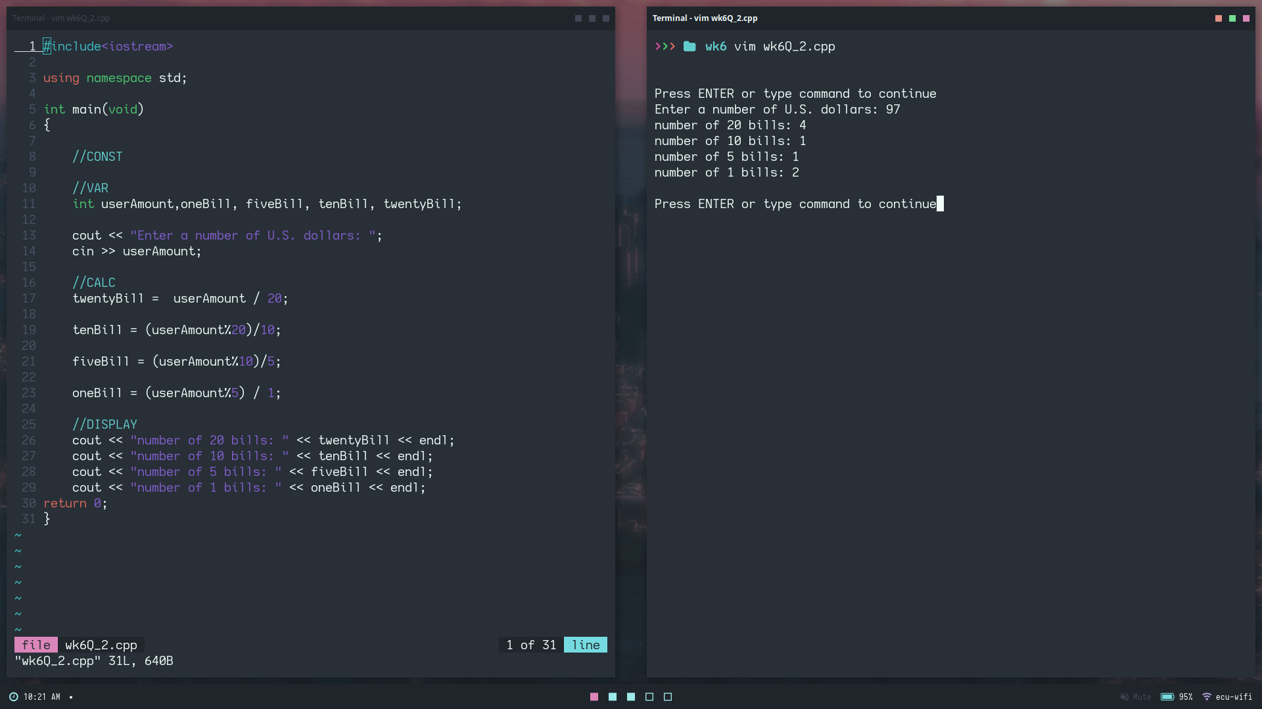
Question 3 INPUT AND OUTPUT

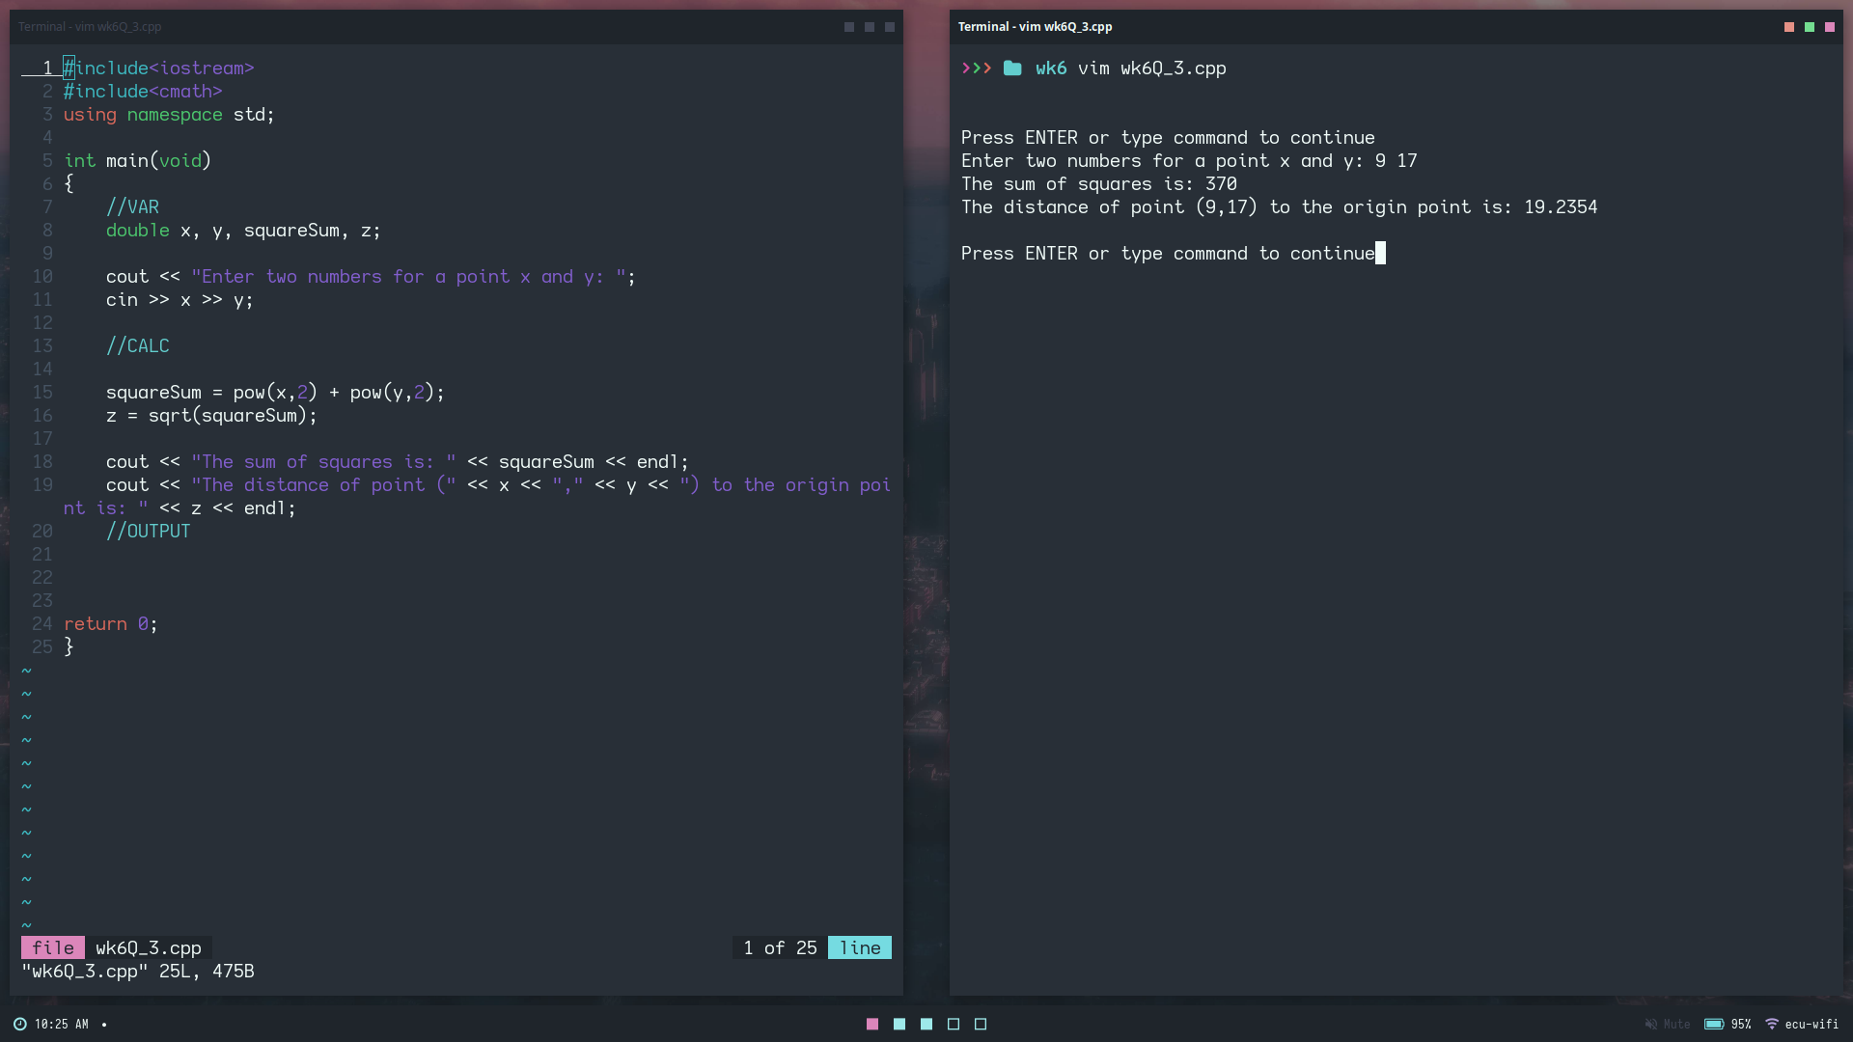

Question 4 INPUT AND OUTPUT
